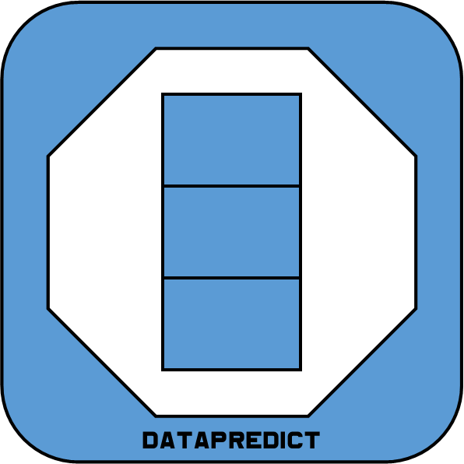
DataPredict For Game Developers
Aqwam Harish (Bin) Aiman

Content
Introduction
General Machine Learning And Game Design
Translating Game Design Language To General Machine Learning Language
Important General Machine Learning Properties For Games (In Order Of Importance)
- Sample Efficiency
- Online Learning
- Computational Efficiency
Machine Learning
- Statistics-Based
- Gradient-Based
- Memory-Based
Deep Learning
- Classification
- Generation
Reinforcement Learning
- Tabular
- Deep
Data In Games
- Collecting In-Game Data Is Easy
- In-Game Data Is Not Noisy
Data Processing (In Order Of Difficulty)
- Selecting Correct Features
- Avoiding Collinearity
- Handling Censored Data
All About Change
- Data Drift
- Concept Drift
- Covariate shift

Law And Ethics For In-Game General Machine Learning
Introduction
Machine learning is a subset of artificial intelligence whose main purpose is to search patterns in data to perform predictions. Very often they have statistical, differentiation or convergence proof in their mathematical formulation. As such, they tend to have high sample efficiency, allowing these models to quickly learn from fewer data.
As for deep learning, it is a subset of machine learning, where it exploits the non-linear learning capabilities of a neural network. While the classical feedforward neural network falls under machine learning, the explosion in its specialization and architectural layers have led to the creation of its own “deep learning” domain. While majority of the specialization and architectural layers have mathematical formulation and their derivative counterparts, they tend to lack convergence proof. To learn these non-linear relationships in the data, they tend to require a lot of “weights” where it would lead to low sample efficiency.
For reinforcement learning, it is a subset of machine learning, where “weights” are stored in tabular forms (prior to the introduction of deep reinforcement learning). Despite having convergence proofs in their mathematical formulation, they tend to be sample inefficient. This is because reinforcement learning balances between “exploring” and “exploiting” environments’ states. Generally, these models would “explore” first and gradually lead to “exploitation”.
Given that machine learning encompasses almost all the deep learning and reinforcement learning, we will call this superset as “general machine learning” as to avoid confusion with the “classical” machine learning algorithms.

General Machine Learning And Game Design
People have always wondered on how you can actually capture the “essence” of game design into the general machine learning. When I first created DataPredict, people saw them being two different terms that have no connection to each other. To be honest, I didn’t know what the use cases for machine learning in games was when I first built DataPredict. It took several years to really understand and appreciate how general machine learning can be used in games. At best, deep reinforcement learning is often used in games in context of research. Very rarely are they used in production systems.
Fortunately for you, my dear reader, I have done all the hard work for you and all you must do is to read through this book. While many books tend to cover the mathematics, codes and jargons used by engineers and researchers who interact with general machine learning in their daily lives, this book will approach things in more conceptual and high-level manner. As a game developer myself, I only included things that matter to most game developers. This means that I will only cover the algorithms at surface level and will only get into details that matter quite a lot for game developers.
Now, back to the question. How do we exactly capture to the “essence” of game design exactly?
The very first thing you need to understand is that games contain a lot of data made by game developers. If you wanted to argue this is not the case, I would like to prove you wrong. How many times have you seen information inserted into items, entities or enemies?
Plenty, right?
Unfortunately, despite the abundance of data generated by the game developers themselves, their utilities tend to be underestimated. Most game developers would see them as nothing more than mere values on how these items, entities or enemies would interact with their games’ environments. It’s such a shame since these can be used to optimize the players’ gaming experience.
This brings up the next point: data generated by the players themselves.

